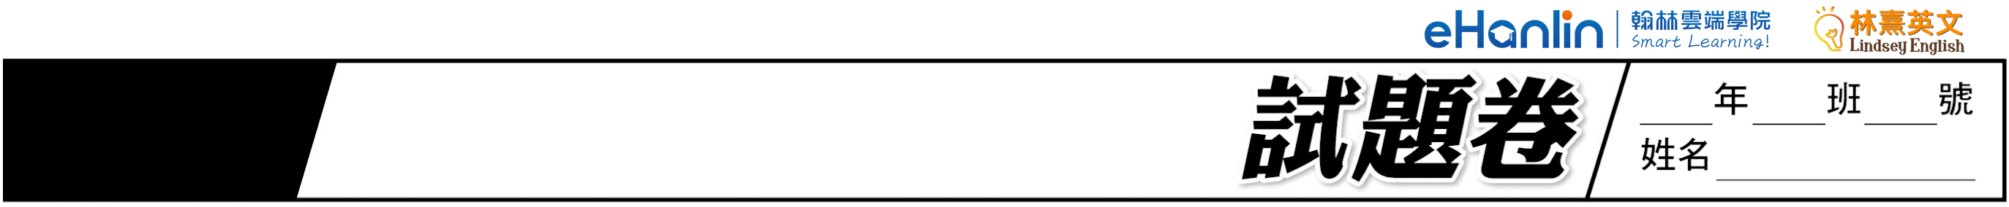
114˙
年國中教育會考
聽力
英語

第一部分：辨識句意(第1-3題)
作答說明：每題均有三張圖片，請依據所聽到的句子，選出符合描述的圖片，每題播放兩次。
（ ）第1題
(A) 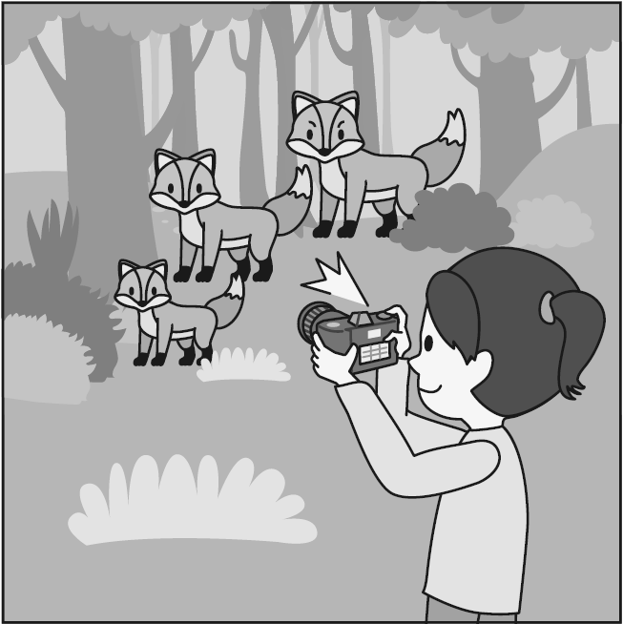 (B) 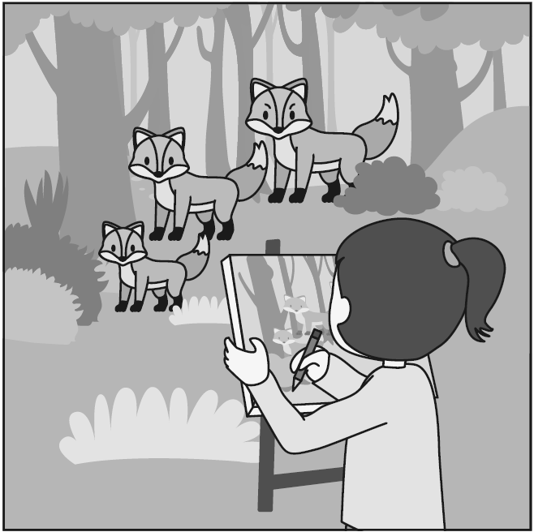 (C) 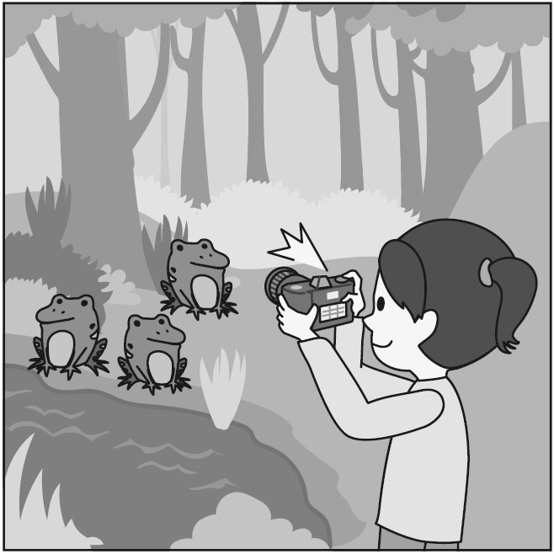
（ ）第2題
(A) 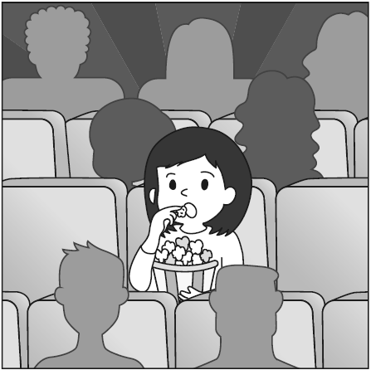 (B) 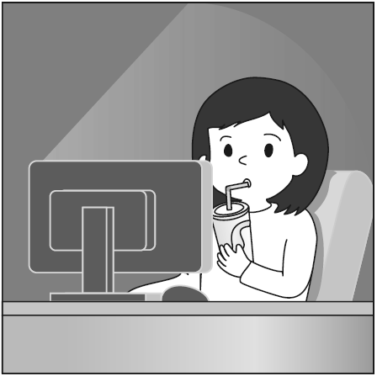 (C) 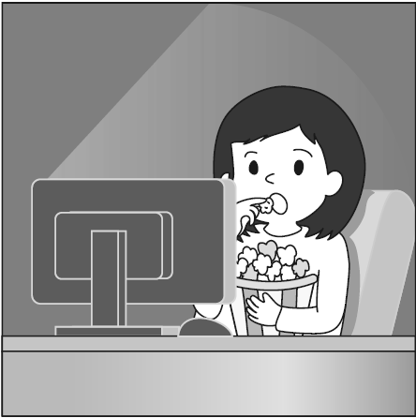
（ ）第3題
(A) 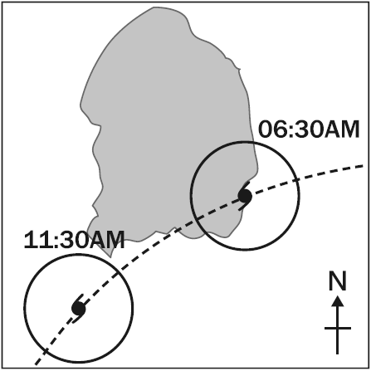 (B) 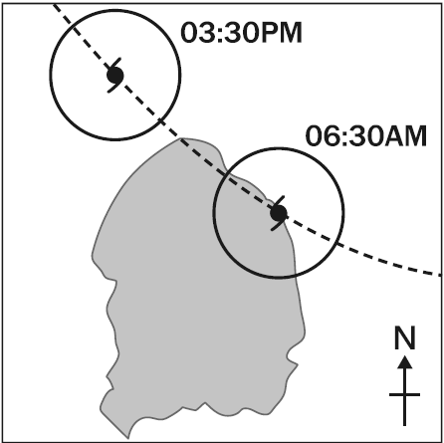
(C) 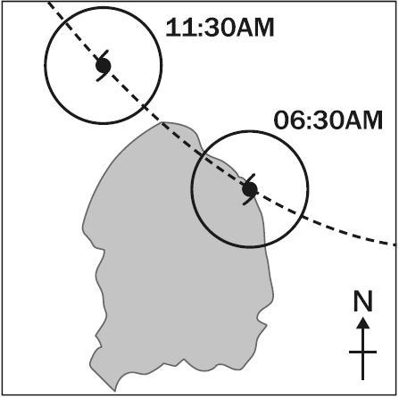

第二部分：基本問答 (第4-11題)
作答說明：每題均有三個選項，請依據所聽到的內容，選出一個最適合的回應，每題播放兩次。
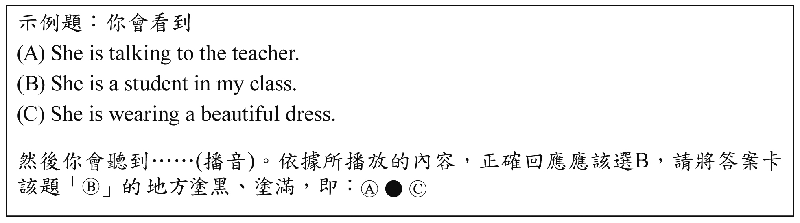
（ ）第4題
(A) I love my job.
(B) Usually by metro.
(C) Usually at six thirty.
（ ）第5題
(A) Just leave them on the table.
(B) They’re in the wrong drawer.
(C) I need them for tomorrow’s test.
（ ）第6題
(A) Yes, a dress.
(B) Your favorite apple pie.
(C) I bought some new plates.
（ ）第7題
(A) Sure, what is it?
(B) Really? That’s crazy.
(C) I haven’t heard of it before.
（ ）第8題
(A) Hurry up! Let’s run for it.
(B) Don’t worry. I can give you a ride.
(C) Sorry. Please come again some other time.
（ ）第9題
(A) Yes, it tastes delicious.
(B) OK. See you at seven.
(C) No, I’m not really hungry.
（ ）第10題
(A) I taught myself.
(B) I won a prize once.
(C) I take lessons twice a week.

（ ）第11題
(A) I’m not sure if he’s with me.
(B) No, have you tried calling him?
(C) Yes, you can ask him by yourself.

第三部分：言談理解 (第12-21題)
作答說明：每題均有三個選項，請依據所聽到的對話或短文內容，選出一個最適合的答案，每題播放兩次。
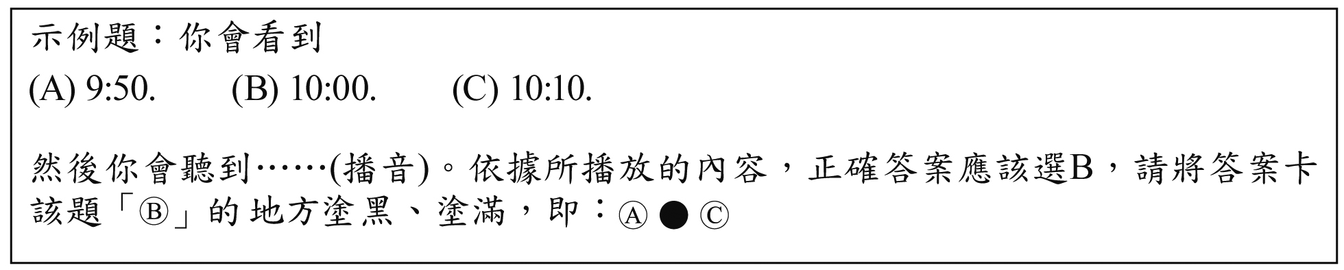

（ ）第12題
(A) Make him a card.
(B) Cook him a nice dinner.
(C) Take him to a restaurant.

（ ）第13題
(A) Cookies, milk, and tomatoes.
(B) Cookies, milk, ice cream, and tomatoes.
(C) Cookies, milk, tomatoes, and sandwiches.

（ ）第14題
(A) In a gift shop.
(B) In a bookstore.
(C) In a clothes shop.

（ ）第15題
(A) He almost hit someone.
(B) He drove around a corner.
(C) He was trying to answer a call.

（ ）第16題
(A) The man’s class.
(B) The woman’s class.
(C) Lily’s class.

（ ）第17題
(A) She tries to make him feel bad.
(B) She wants him to enjoy his birthday.
(C) She can deal with dirty plates herself.

（ ）第18題
(A) Because she wants a better job.
(B) Because she already found a job.
(C) Because she lied in the job interview.

（ ）第19題
(A) What days the garbage truck comes.
(B) How garbage is collected in Taiwan.
(C) Which music garbage trucks in Taiwan play.

（ ）第20題
(A) She thinks the man knows Alan well.
(B) She does not think Alan will move to America.
(C) She thinks Alan will move to America
next year.

（ ）第21題
(A) The game will begin soon.
(B) The snacks at the food stands are free.
(C) People have to wait until the rain stops.

0試題結束0

